## Update Data Send URL

**Note:**

**The below action should be carried by SQL DBA who has admin level knowledge of SQL Server.**

* Open SQL Management Studio.
* Run below query against SunSystemsQA database

USE SunSystemsQA

UPDATE lasAG_SYSTEM SET DAT_TEXT1='http://DESTINATIONSUNAPPSERVER/sunsystems-connect/wsdl/'

WHERE DAT_TEXT1='http://SOURCESUNAPPSERVER/sunsystems-connect/wsdl/'

* After the update, validate by using below query if record is updated.

USE SunSystemsQA

SELECT * FROM lasAG_SYSTEM WHERE KEY_ID='VAR_EndPointURL'

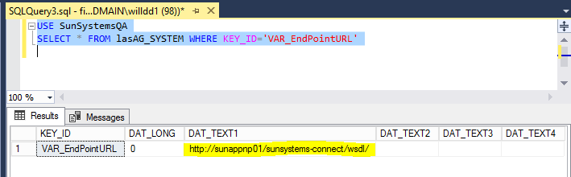

## Update QAAdmin ( SQL User ) Permission on Sun Databases

**Note:**

**The below action should be carried by SQL DBA who has admin level knowledge of SQL Server.**

* Open SQL Man. Studio
* FINPPDBLI ( SQL Instance ) > Security > Logins
* Double click “ QAAdmin “ user
* Click “ User Mappings “

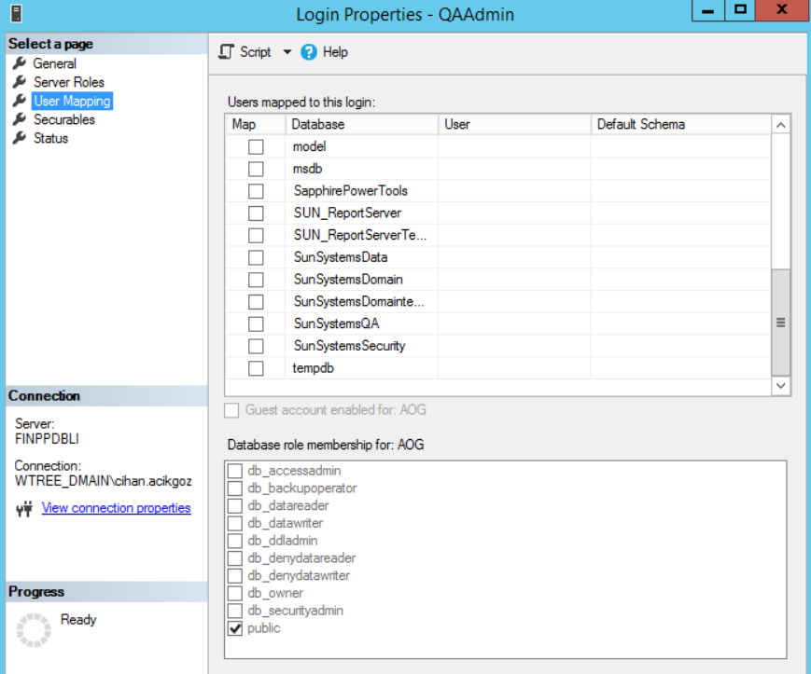

* Assign “ **dbowner** “ right on SunSystemsData, SunSystemsDomain and SunSystemsQA databases.

## Refresh Connection Infor Q&A from QA Maintenance

* From Windows Start Menu > run Maintenance

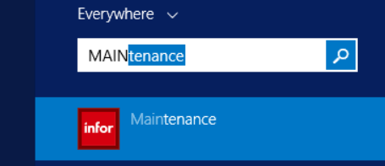

* Click OK

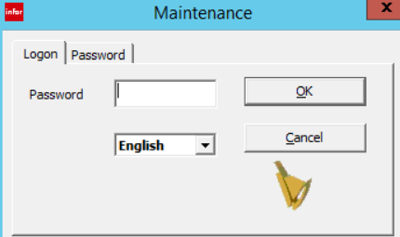

* Click Client Setup

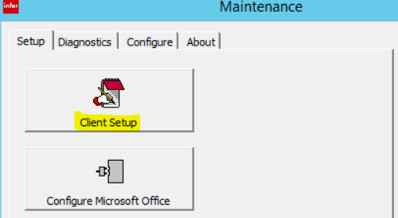

* Select **Query & Analysis**, then click “ **Test Connection** “ ( If connection fails, re-enter QAAdmin password details – Password details can be retrieved from Password Manager Application )
* Once connection successful, click OK.

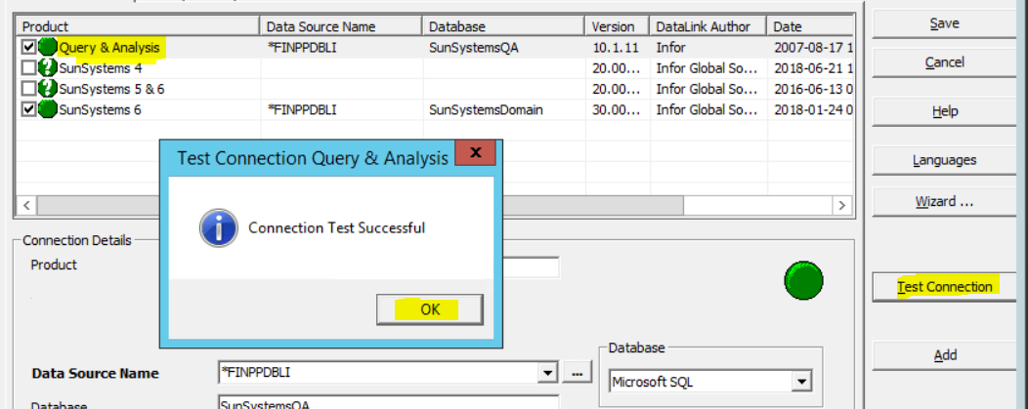

* Now, select **SunSystems 6**, then click “ **Test Connection** “ (If connection fails, re-enter QAAdmin password detail )
* Once connection successful, click OK

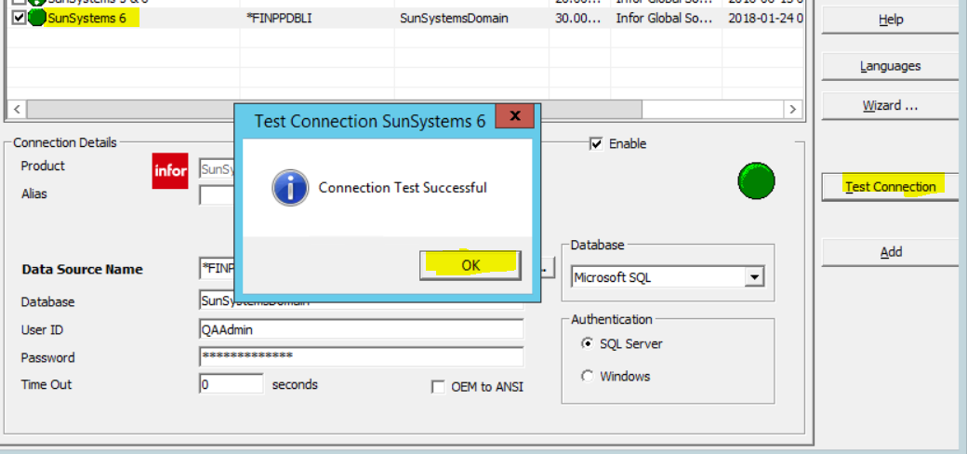

* Click Save button.

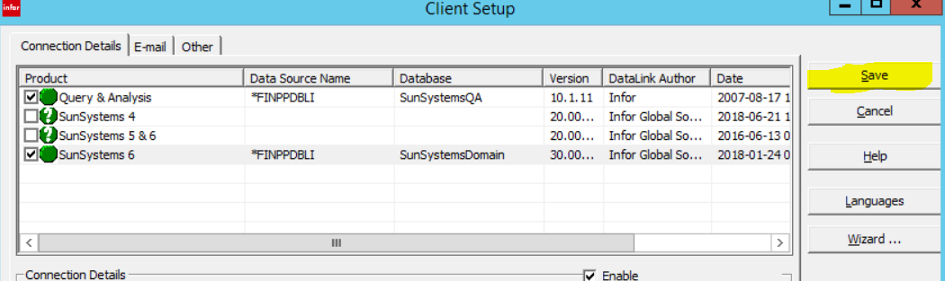

* Click Exit to close programme.

